Meeting 28
Course / Class #: CECS 4800

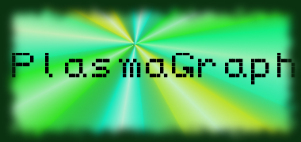
Date: 1 May 2014
Project Name: PlasmaGraph

Has been done:
- Final test data files obtained. (Contain incorrect header variable name - “headers” instead of “header”. Will add additional check for “headers” and “Headers”, just to be complete.)
- Work on SRS, SPMP (Section 5 remaining.), SDD (Table of necessary diagrams to make for document completion and state diagram sketches.), and Presentations. (First text draft of Client presentation.)
- Additional work on Javadocs.
- Sent e-mail regarding Matlab file requirements for use in PlasmaGraph to Plasma Lab students.

What will be done:
- Remaining documentation. (SPMP, SRS, etc)
- Finish presentations, and start gathering materials and designing for project poster.
- Test product with new data before presenting to client for final verification before Plasma Lab presentation scheduling.
- Finish Javadoc.

Materials Used: 2x Computers, Internet connections, Microsoft Visio / Dia (Diagramming Tools), OpenOffice Writer / Microsoft Word 2013 (Document-writing Tools), Eclipse / NetBeans IDE (Programming Tools).

Group Members: ________________________________
Gerardo A. Navas

________________________________
Daniel Quintini
Professor:

________________________________
Prof. Luis A. Ortiz

